# Ultrasonic Sensor and Accelerometer

# Accelerometer

### Pins

The pins used are P6.4 for SDA and P6.5 for SCL.

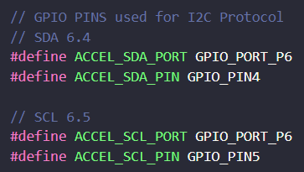

### I2C Module

The I2C module used is EUSCI_B1_BASE.



### 

### Timer

The timer used is the TIMER_A1_BASE, we use instance 0 - TA1_0.

**Timer used to get accelerometer readings at regular intervals (interrupts) to get accelerometer readings (accelX Y Z, etc) and to calculate hump height.**

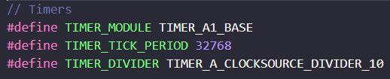

### upConfig

Uses ACLK (32768), divider = 10, tick period = 32768

Thus, interrupt every 0.1s.

// Comment is a typo, has since been rectified in code.

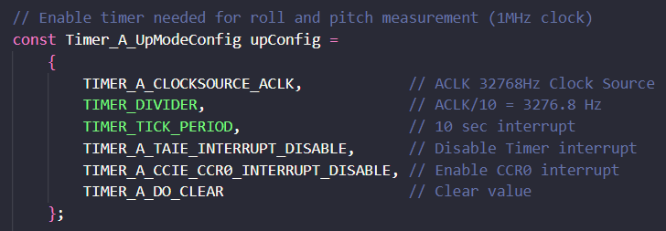

### i2cConfig

Uses SMCLK, 3MHz.

400KBPs is what the datasheet says MPU-6050 needs for I2C.

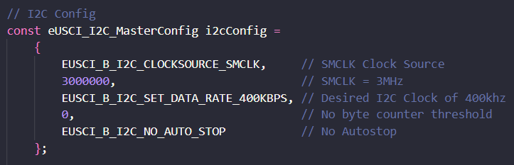

**Interrupts**

Interrupts used:

Interrupt0 to transmit (reset) and receive (read data) to/from MPU-6050

EUSCI_B_I2C_TRANSMIT_INTERRUPT0

# Ultrasonic

### Pins

Four ultrasonic sensors are/can be used.

The front sensor uses P2.3 for trigger and P1.7 for echo.

The right sensor uses P5.1 for trigger and 5.0 for echo.

The back sensor uses P3.5 for trigger and P5.2 for echo.

The left sensor used P3.6 for trigger and P3.7 for echo.

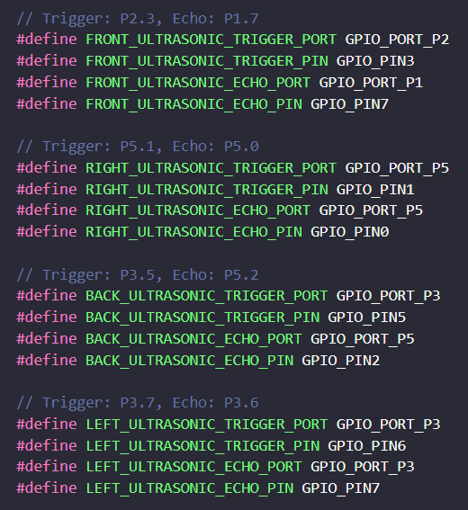

### 

### 

### 

### 

### 

### Timer

**The ultrasonic timer** used is TIMER_A3_BASE and it **is triggered every 1ms**.

Used to measure the distance.

Switched to TA3_0 to avoid other timers.

Sampling to be tied in with other modules when integrated.

### 

General interrupt every ms

Period num of samples we

Avg to max 20 vals

### Filtering of data

### EMA

We employ an EMA aggregation of data to provide us with a smoother filter of averages. SMA simply calculates an average of sensor data, while EMA applies more weight to sensor data that is more current. As such our team has implemented an 80 | 20 split formula whereby 80% of the previous value is added together with 20% of the current value to give us a much smoother data sample. Even with any huge spikes in the data, the EMA formula ensures the final average is not affected too drastically.

Code snippet :



### High pass filter

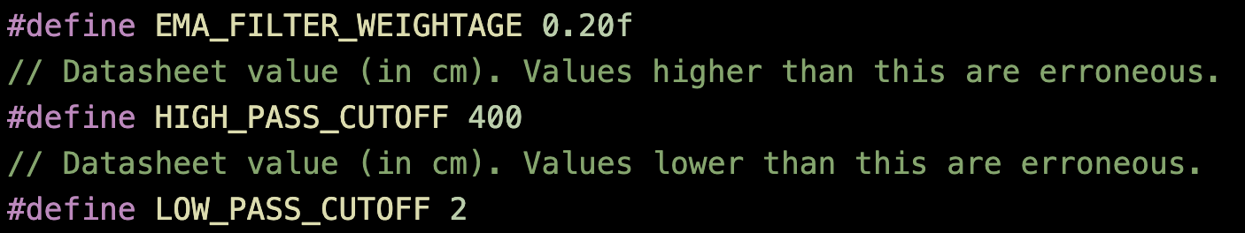

We have the upper bound of 400 as a high pass filter and the lower bound of 2 as a low pass filter, thus values beyond (>400) and less than (<2) will not be included in the datasheet for more accurate results. This optimized data is now more suited to be used for future calculations such as distances traveled by the robotic car.

### Interrupts

T32 interrupt is used for utility delay to trigger ultrasonic sensor pulse for ranging.



**TA2 is used to measure time for ultrasonic sensor pulse** - then used in distance calculation.

**Separate from Accel timer because we pause it to get the counter value when calculating distance, this could interfere with the accelerometer readings.**



### UpConfig

